Name : Sakthi Manoj R Reg No : 192324236
PROGRAM 16
Explore the USArrests Dataset
Aim:
To analyze the USArrests dataset using summary statistics, maximum and minimum values, correlations, and visualizations.
Procedure:
Step 1: Open RStudio or the R console on your computer.
Step 2: Load the built-in USArrests dataset using data("USArrests").
Step 3: Use summary() to display summary statistics for the dataset.
Step 4: Use which.max() to identify the state with the largest Rape value, and max() and min() to find the maximum and minimum Murder values.
Step 5: Use cor() to calculate correlations among the numeric variables.
Step 6: Identify states with Assault values above the median and Murder values in the bottom 25%, if required.
Step 7: Create visualizations such as a histogram, density plot, scatterplots, and bar graphs.
Step 8: Display and observe the statistical results and plots.
Output :
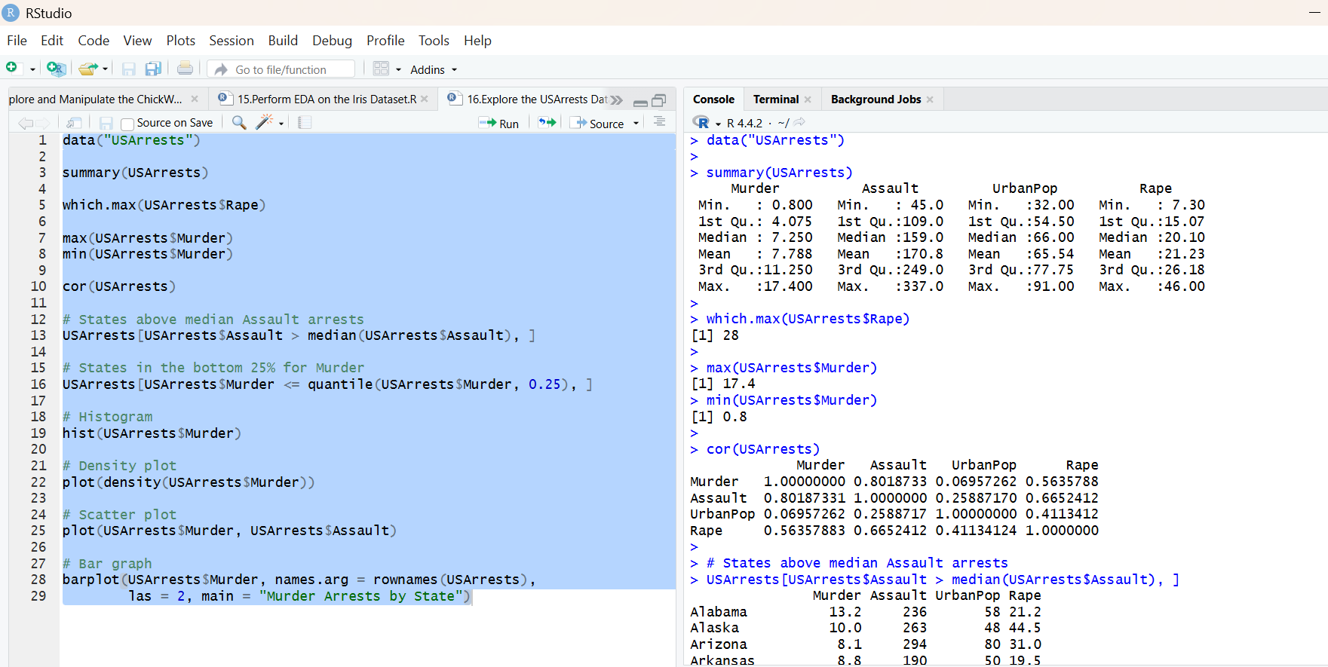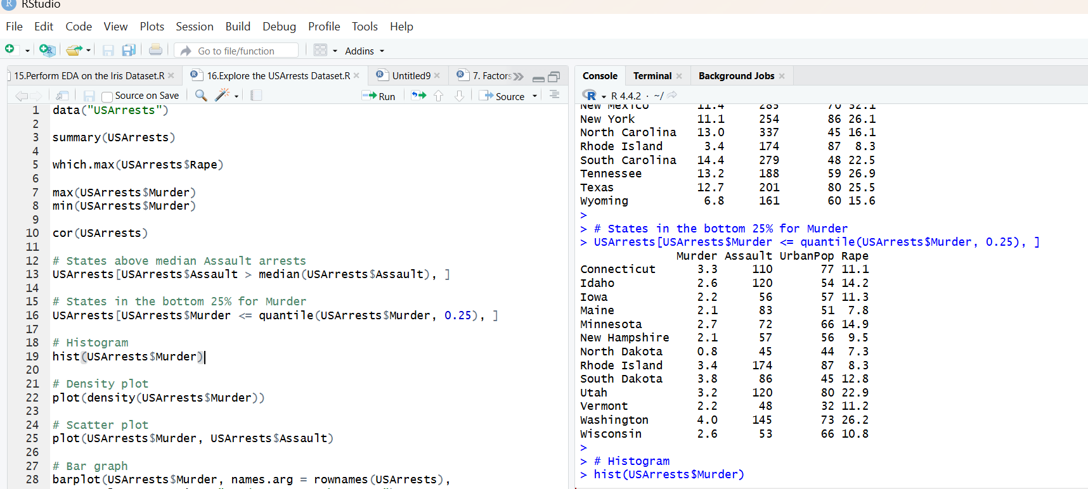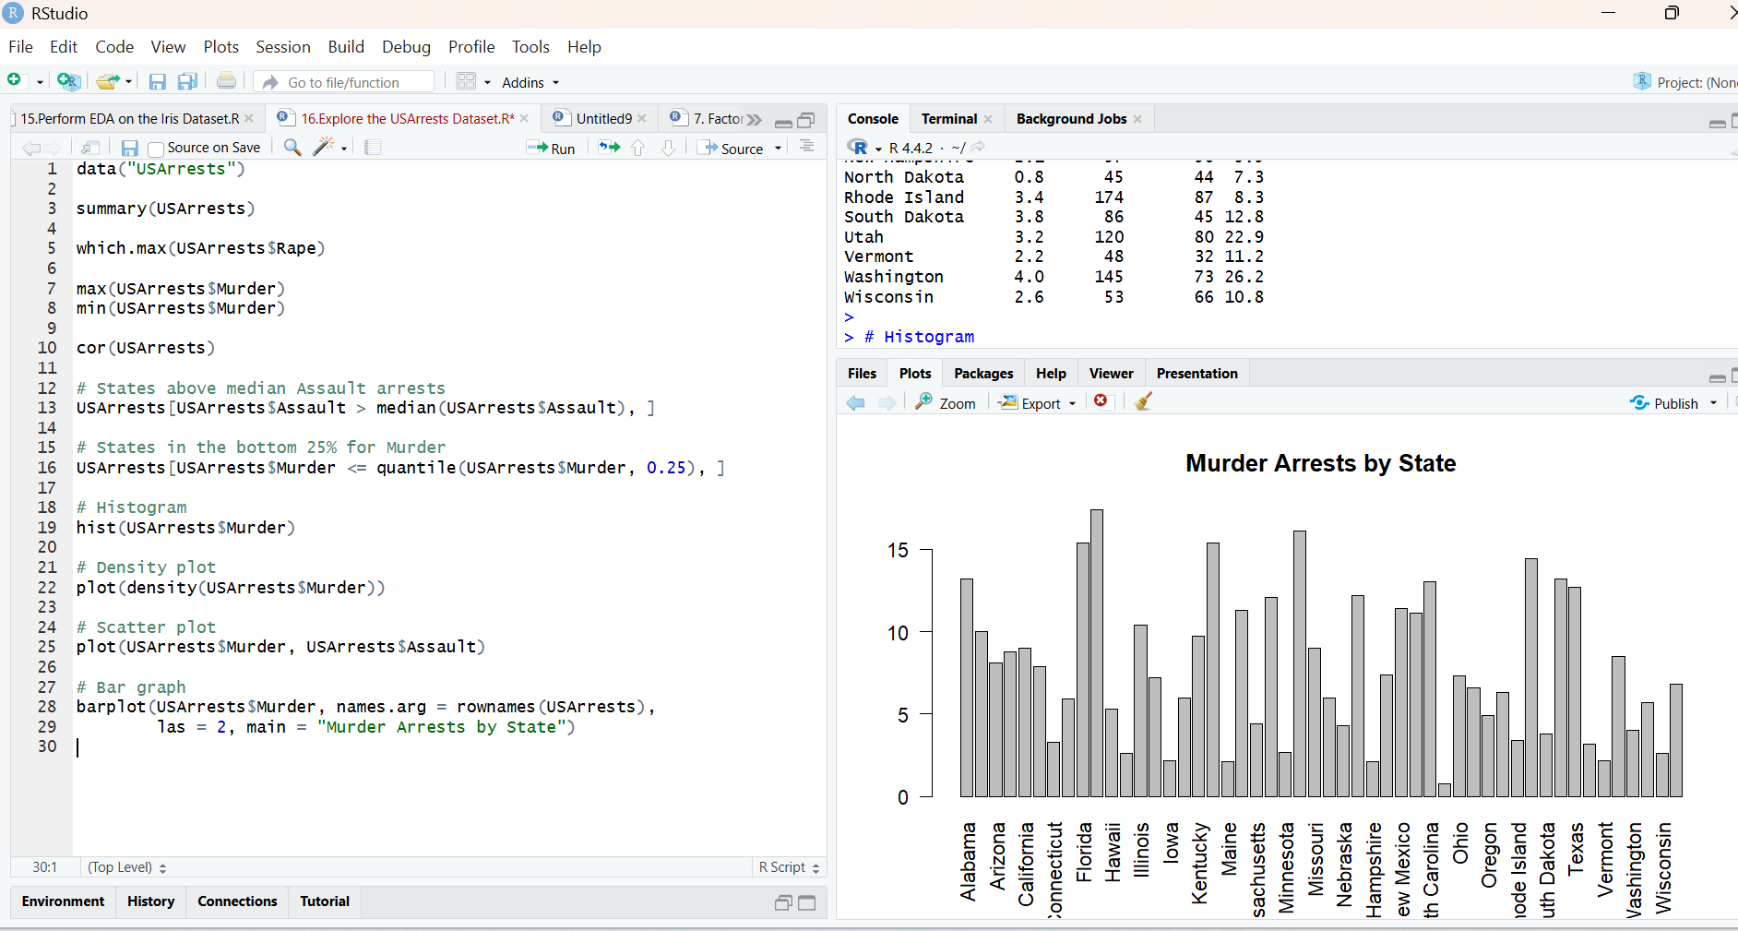
Result:
Hence the output is verified successfully.

